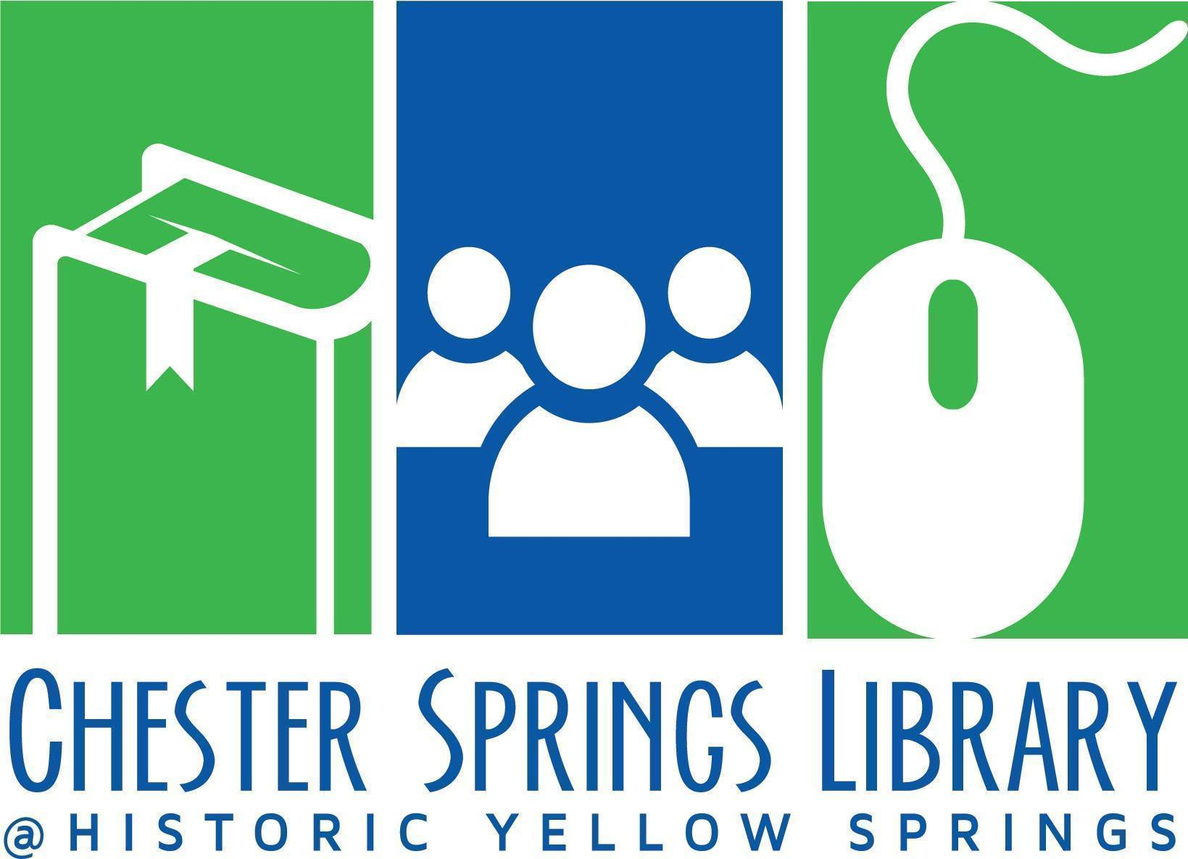

Board of Trustees Meeting Agenda

September 16, 2024 at 6pm F2F@ Library
- Call to Order (Kim)
- Approval of Minutes from August Meeting (Kim)
- Introductions (Nancy, Vidhya, All) (5 min)
  - Samantha Heckler-O’Conner, Mark Quinlan
- Treasurer’s Report (10 min)
  - Current Financials (Peter)
  - Did You Know Campaign? (Kim)
    - FYI: Facebook post
    - CSL Website, Pie chart from Legislative Bfast?
- 2025 Library Director Goals (Nancy-15 min)
  - Presentation of 2025 goals for Board comment
- Board Items
  - Facilities Committee Update (10 min)
    - Basement Foundation (Kim and Nancy)
      - Update/Discuss Next steps
    - HYS Sewer Bill (Peter and Kim)
      - Update/Discuss Next steps
  - Fundraising Subcommittee (Stef Anderko, Branden Hydutsky, Caroline Perry) (15 min)
    - Annual Appeal
      - Key dates: Planning Mtgs, Kick Off, etc.
      - Poster and Coupon
    - Donor Thank You Reception (Oct 20, 10-noon) Updates
      - Invite List
      - Giveaways and e-Vites
      - Catering/Insurance/Capacity Limits
    - Timeline for Annual Appeal
  - Reminders (for in person October Board Meeting) (5 min)
    - 2024 Board Photo–All
    - Capital Expenses: Outdoor picnic table options (Branden)
  - Review Action Items Log (5 min)
- Director’s Report/General Library Updates (Nancy) 15 min
  - Facilities
  - Programming
  - Library Business
  - Meetings/Committees
  - Social Media
  - Stat Report
- Adjournment
Next Board of Trustees Meeting Oct 15, 2024 at 6pm F2F@ CSL👍

