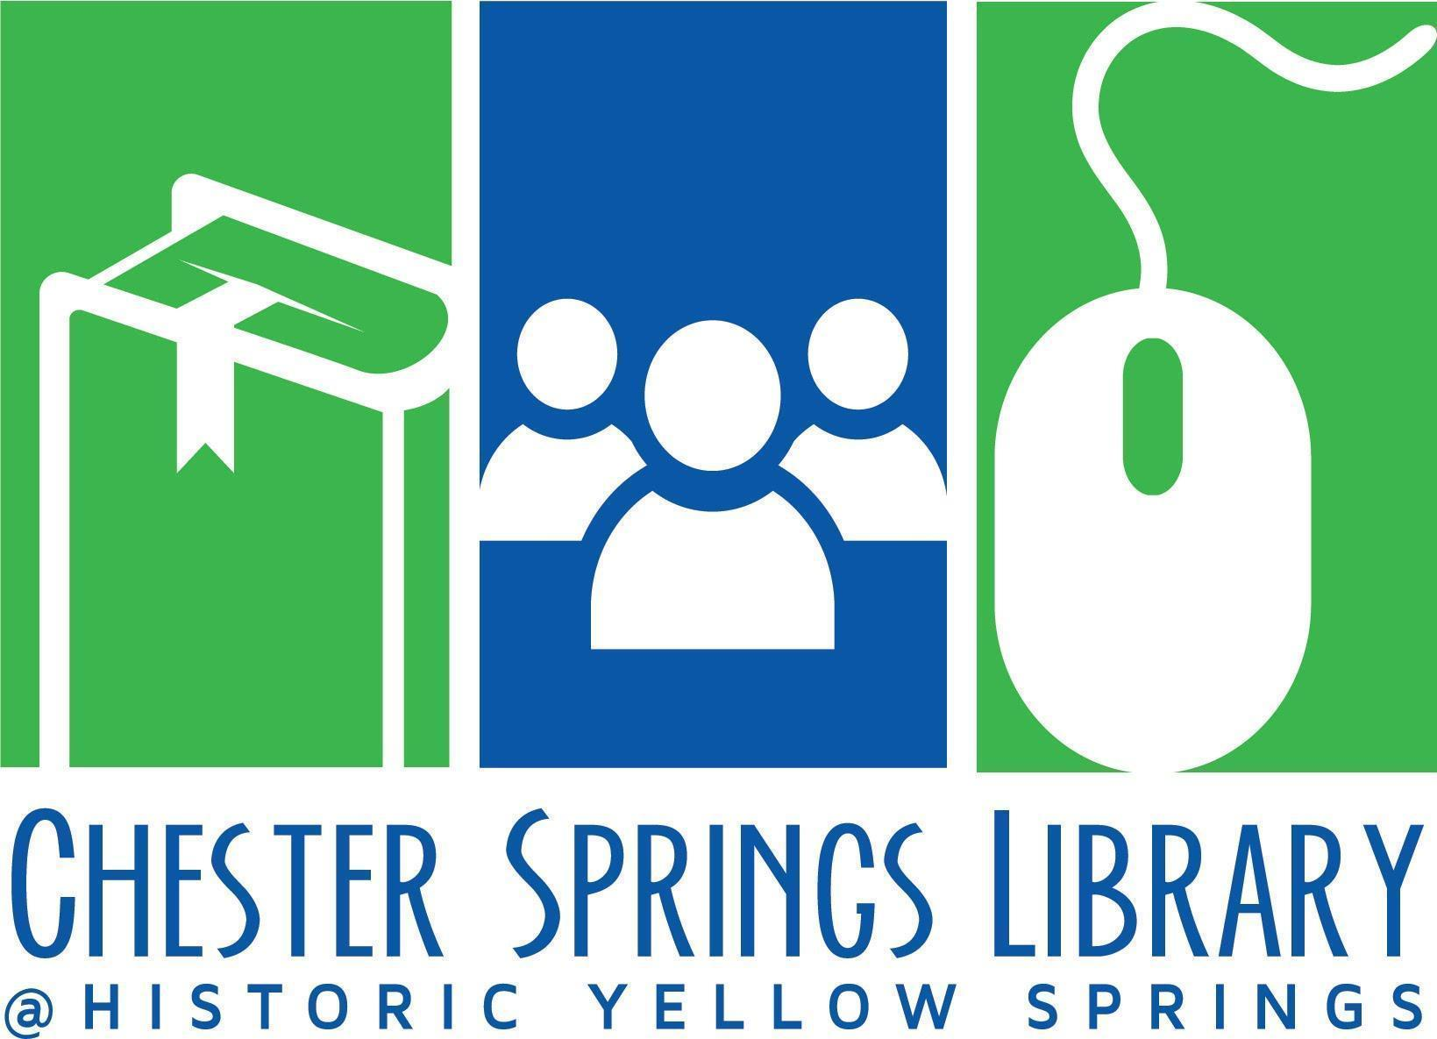

Board of Trustees Meeting Agenda

August 20, 2024 at 6pm @ Zoom
- Call to Order (Kim)
- Approval of Minutes from June Meeting (Kim)
- Treasurer’s Report
  - Current Financials (Peter)
  - Did You Know Campaign? response from WP Twp (Kim)
- Board Items
  - HYS Sewer Bill (Peter and Kim)
    - Outcome of discussion with Tim and HYS Treasurer
    - Discuss Next steps
  - Staffing–Susie’s replacement (Vidhya and Nancy)
    - Job posting update
    - Feedback from Susie’s exit interview (Peter and Kim)
  - Capital Expenses
    - Outdoor picnic table options (Branden)
  - Fundraising Subcommittee (Stef Anderko, Branden Hydutsky, Caroline Perry)
    - August/Sept dates for annual appeal planning meeting
    - Donor Thank You Reception ideas
    - Invite list
  - 2024 Board Photo
    - Sept Meeting (dress nice ( : )
  - Review Action Items Log
  - Strategic Plan—Item 2 (Time permitting)
- Director’s Report/General Library Updates (Nancy)
  - Facilities
  - Programming
  - Library Business
    - Website redesign subcommittee
      - Board Members? Staff?
      - Next Steps?
  - Meetings/Committees
  - Social Media
  - Stat Report
- Adjournment
Next Board of Trustees Meeting Sept 17, 2024 at 6pm at CSL

