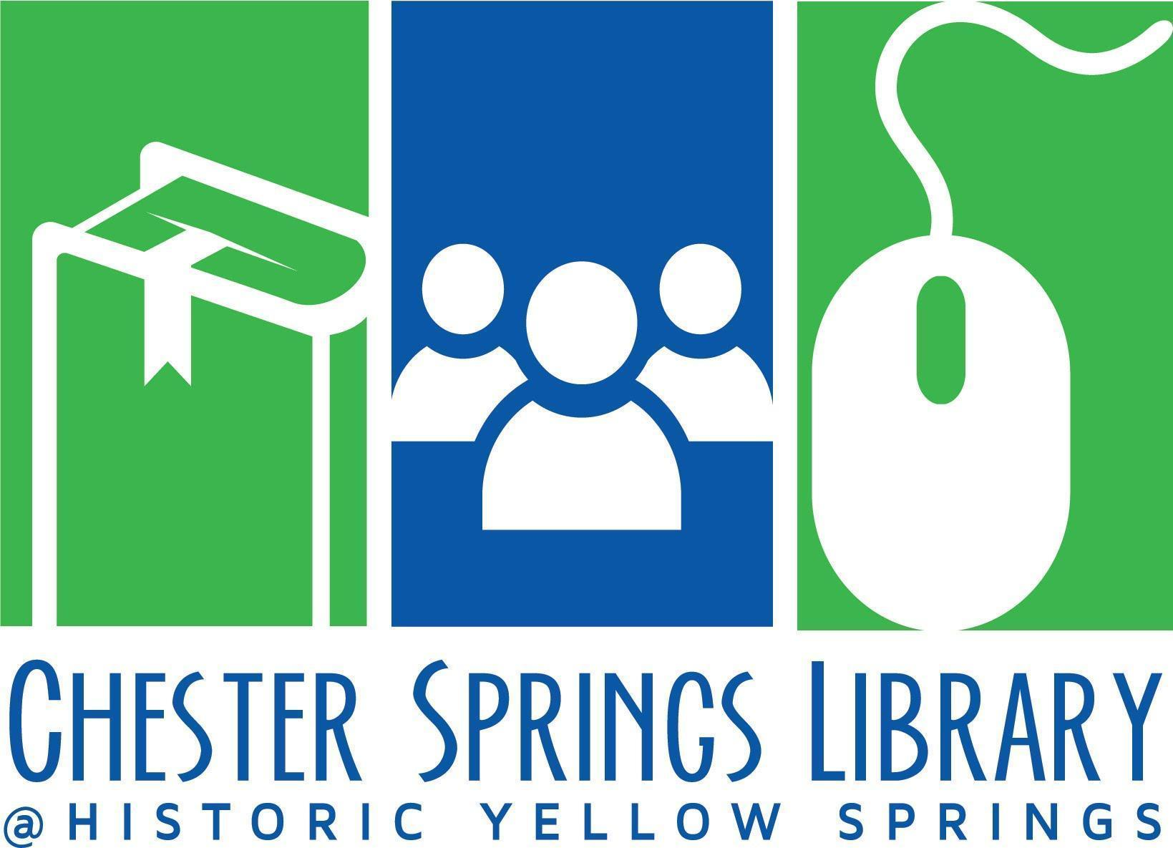

Board of Trustees Meeting Agenda

June 18, 2024 at 6pm @ CS Library
- Call to Order (Kim)
- Approval of Minutes from April Meeting (Kim)
- Treasurer’s Report (Peter)
  - Current Financials
- Board Items
  - HYS Sewer Bill
    - Response from Susan Boswell
    - Response from Tim/HYS Board (if rec’d)
  - Capital Expenses
    - Outdoor picnic table space (Brendan–options)
  - Policy Subcommittee
    - Review Schedule (Stef)
  - Fundraising Subcommittee (Stef Anderko, Branden Hydutsky, Caroline Perry)
    - August/Sept dates for annual appeal planning meeting
    - Donor Thank You Reception ideas
  - Review Action Items Log
  - Strategic Plan—Item 2 (Time permitting)
- Director’s Report/General Library Updates (Nancy)
  - Facilities
  - Programming
  - Library Business
    - Website redesign subcommittee
      - Board Members? Staff?
      - Next Steps?
  - Meetings/Committees
  - Social Media
  - Stat Report
- Adjournment
Next Board of Trustees Meeting August 20, 2024 at 6pm via Zoom
Vidhya will lead the meeting as Kim has a conflict.

